Task3: List countries,region,flag,subregion

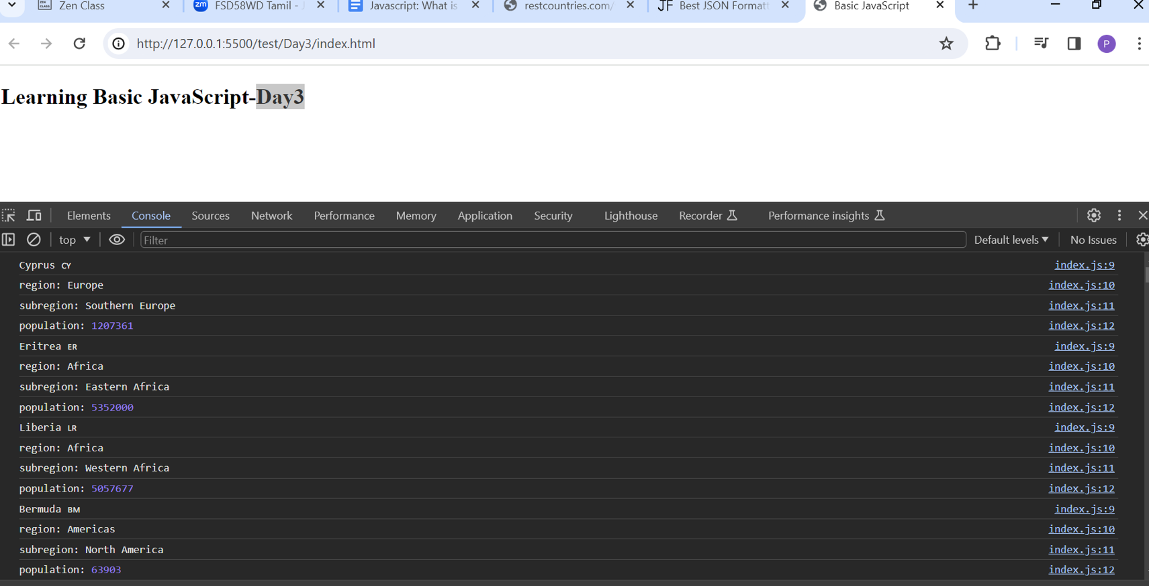

Task3: compare same two objects without order

let obj1 = { name: "person1", age: 5 };

let obj2 = { age: 5, name: "person1" };

function areObjectsEqual(obj1, obj2) {

if (keys1.length !== keys2.length) {

return false;

}

for (var i = 0; i < key1.length; i++) {

if (obj1[key] !== obj2[key]) {

return false;

}

}

return true;

console.log(areObjectsEqual(obj1, obj2));

}

Output:

